Name: Pranali Sonawane
Subject: MCSA
Date: 8-12-2025
Lab : Share Permission

Server1 :
- Tools Active directory user and computers Microsoft Users Right click on User Project1 create group create 3 users
- Create folder on C drive name Project1 in that create 2 text documents suppose abc and xyz
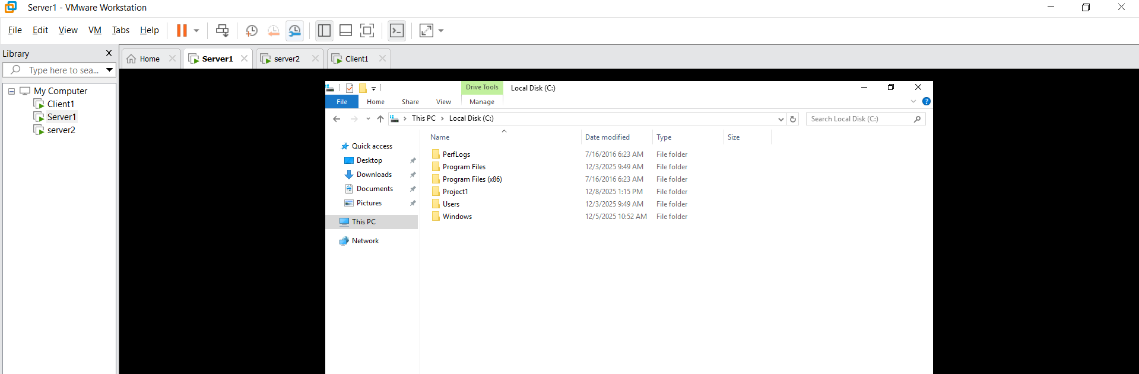

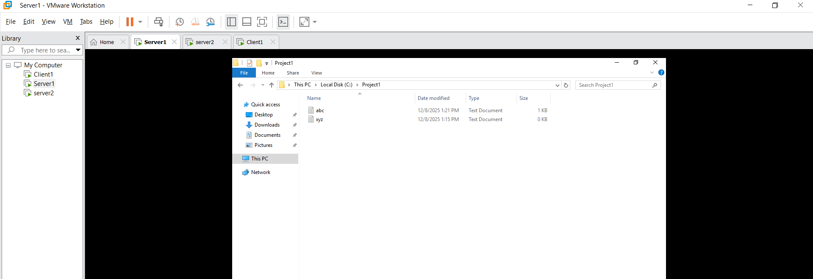
- Project1 Propertise Users has full Control
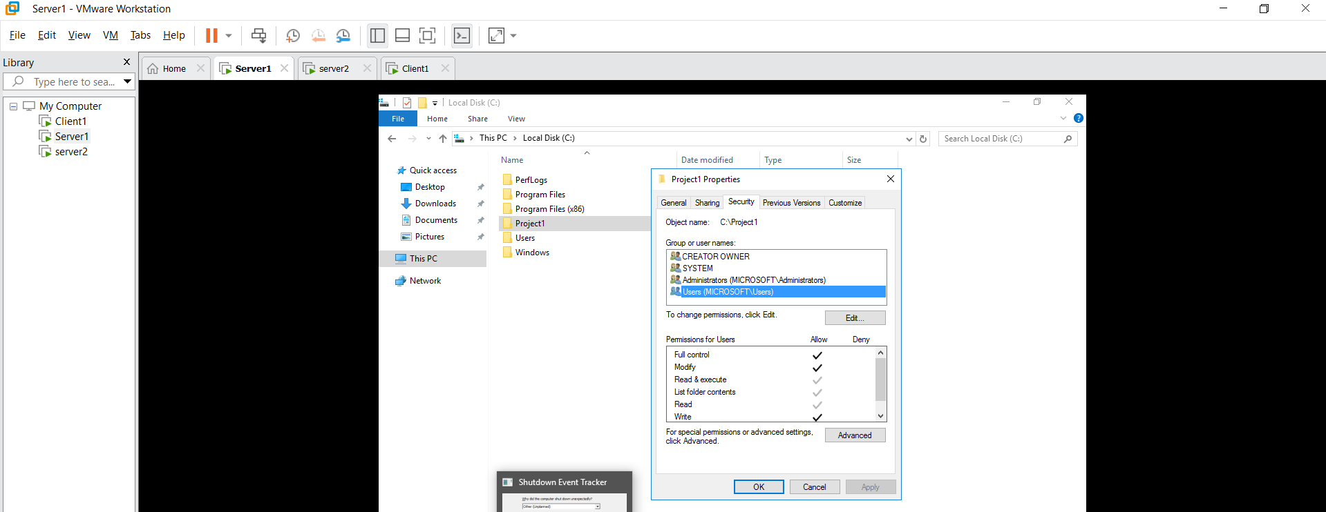
- Project1 Sharing 3 users :
- Abhi – Full Control
- Pooja – Read
- Neha – Change
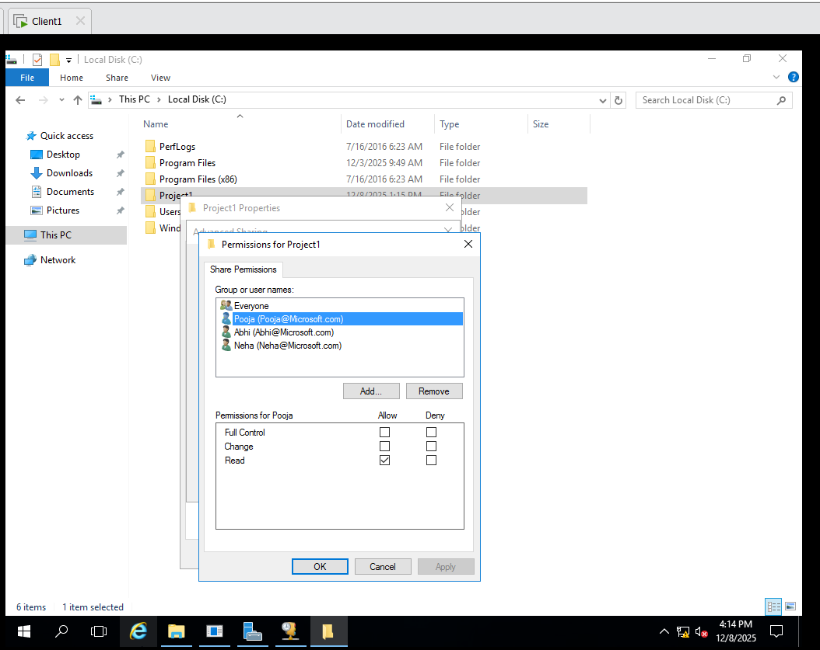
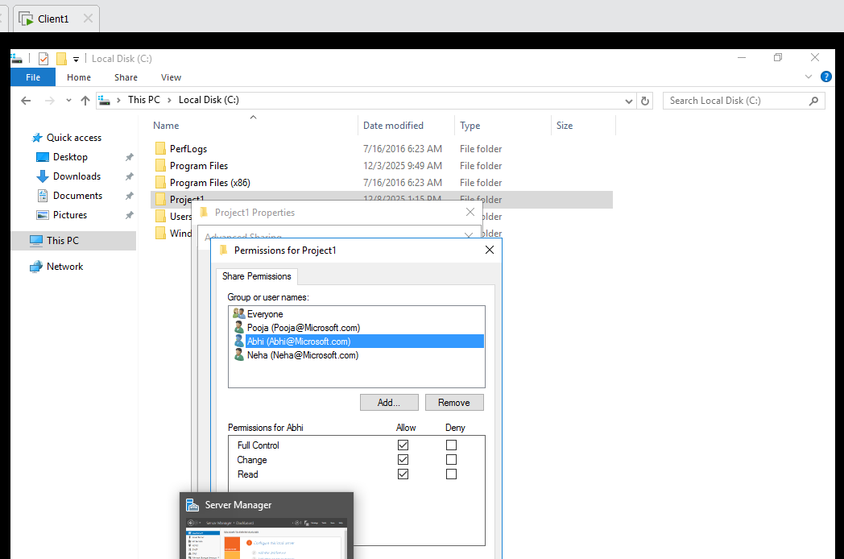
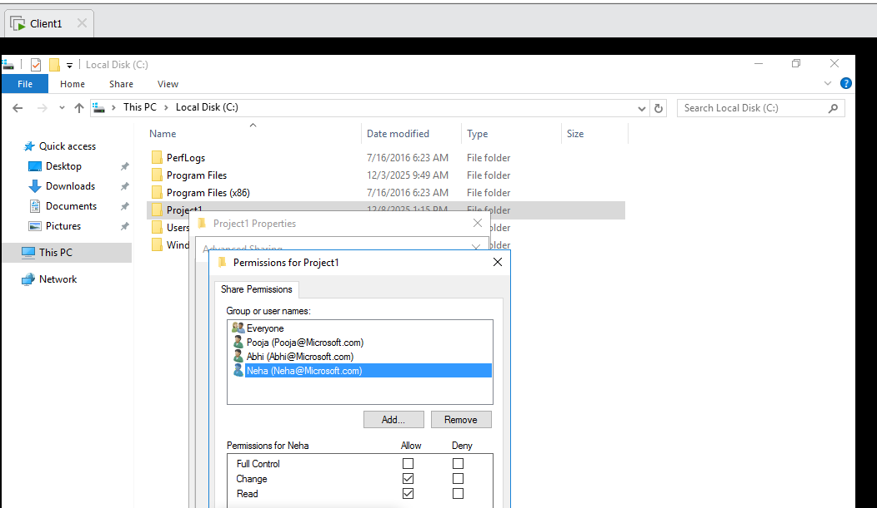
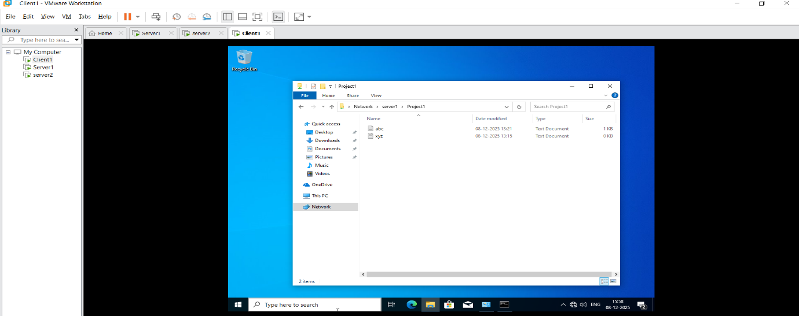

Client 1: - Login Username : Microsoft\Administrator
Password: Password@123
Run \\server1 -- show Project1 Folder
\\server1\c$ -- access only by Administrator
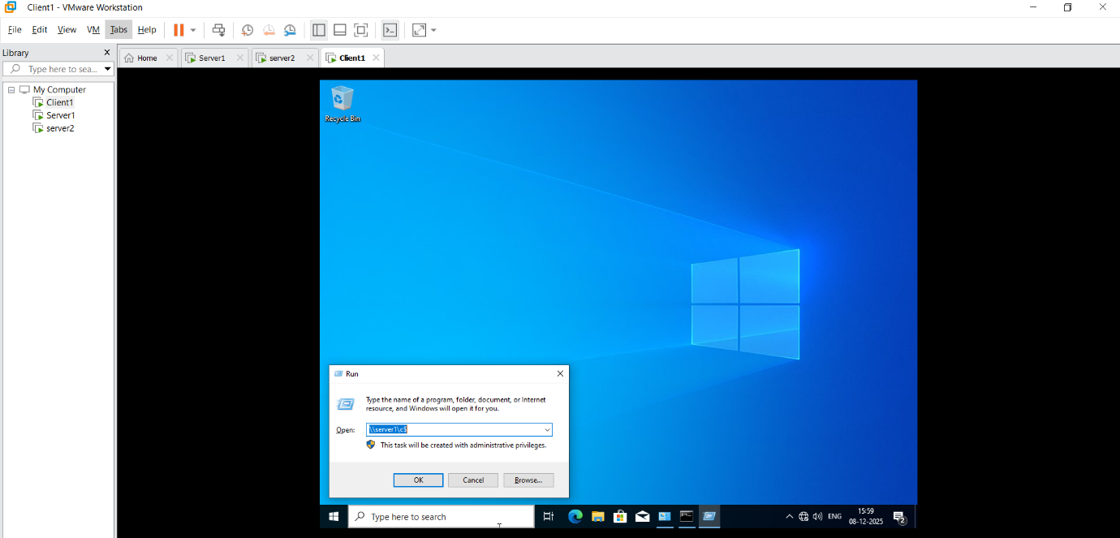
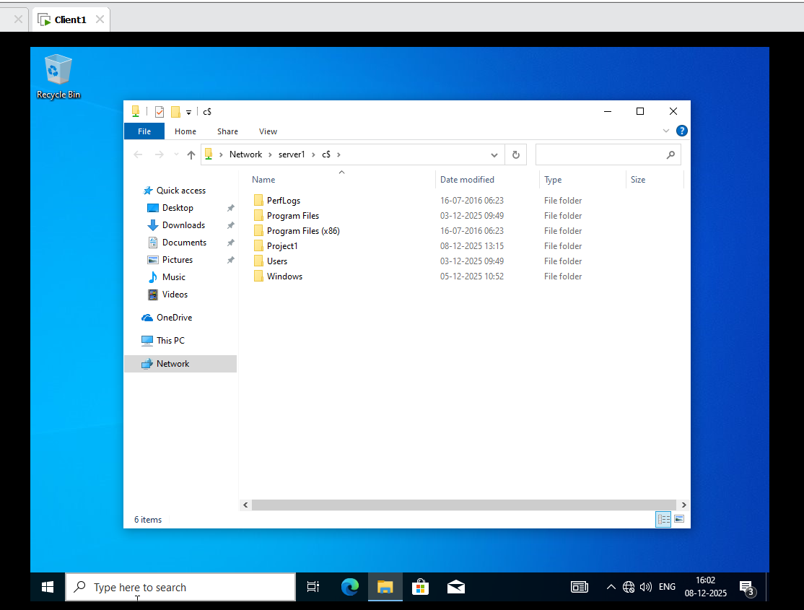

Client 1: - Login User such as Abhi
Run \\server1 -- show Project1 Folder
Show Access is Denied

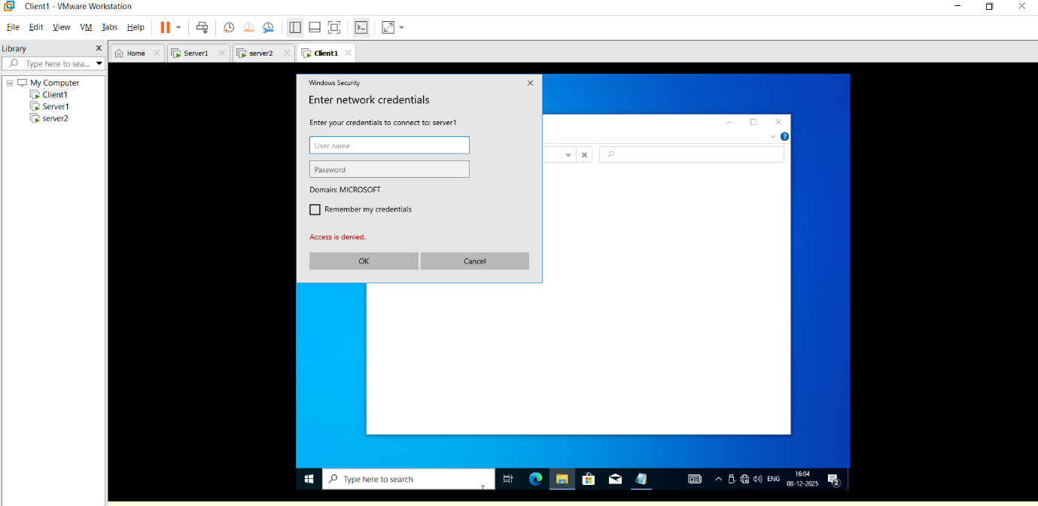
Run \\server1\c$
In Project1 Folder Change on txt File saved it then show Error you do not have a Permission

